CURRICULUM VITAE

RAMANUJ SHAH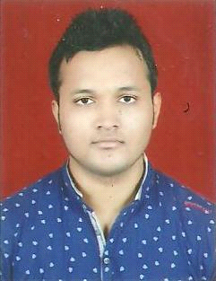  E-mail: ramdeepshah@gmail.com  Mobile No- +91-7898375756  Present Address  H.No- 13/A Awadhpuri BHEL Bhopal  Distt. Bhopal (M P)  Pin code:462022  Mob.+91-7898375756  Permanent Address  H.No- A1/5 Nehru Vihar J.P Nagar Rewa (M.P.)  Pin code:-486450  Personal Information  Name : Ramanuj Shah  Father’s Name : Mr.Shiv Prasad Shah  Mother’s Name :Mrs. Surekha Shah  Date Of Birth : 18/04/1992  Sex : Male  Nationality : Indian  Marital Status : Single  Linguistic Repertoire : English, Hindi | Career Objective:  To secure a challenging job that explores best of creative and learning skills and hence provide a work environment aimed toward constant and deserving growth.  Educational Qualifications:  Qualification Institute / Board Year of passing Percentage  B.E Mechanical Engineering. NRI Institute of Information Science and technology (RGPV) Bhopal M.P 2015 6.45%  Higher sec. CBSE Board 2011 68%  High School CBSE Board 2009 50%  Assets:  - Highly motivated & enthusiastic to work in a team.  - Adjustable to any environment.  - Effective Communication skill and leadership  qualities.

Points leading me towards success:
- Technical Knowledge, Awareness, Commitment, Commitment towards work and enthusiasm to learn, able to meet targets.

Area of interest:
- Evaporter ,Production Engineering, Boiler.

Software design:
- Auto cad & design solutions.

Activity:
- Participate in debates & discussion.
- Event Management at various occasions.

Seminar and Workshops:
- 3 Day s workshop on Basic Robotics system.

Major training:
From : My Car Maruti Suzuki at Jensi Stop Bhopal.
Topic on :Manufacturing of Car & Car Repairing.
Duration :(16 June 2014-30 June 2014)
Projects:

Major Project :Mine detector with arms.

Extra-Curricular Activities:
- Participate in Festival of Technical Paper & Innovative Model (SRIJAN-2014)
- Participate in Social Debate Competition.
- Caption of School Cricket Team.

DECLARATION:
- I have by declare that the information furnished above is given with full sincerity and honestly. I bear the responsibility for the correctness for all mention above information.

Place :

Date :

(RAMANUJ SHAH)

